**Assistant widget**

Assistent Wigget content could be changed from Admin Panale.

1. Open Admin panel;

2. Select for top menu **CMS > Static Blocks**

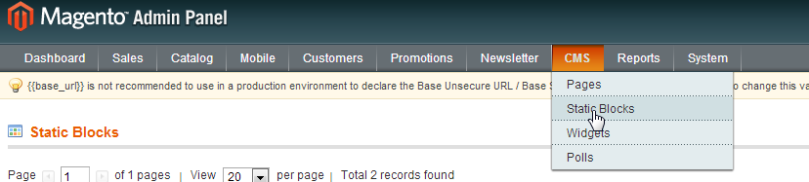

3. Select **Assistant banner** block from the list

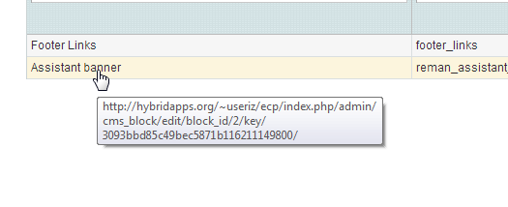

4. I n the opened page you can easily edit the content of the block using editor tools (Text and Banner Image)

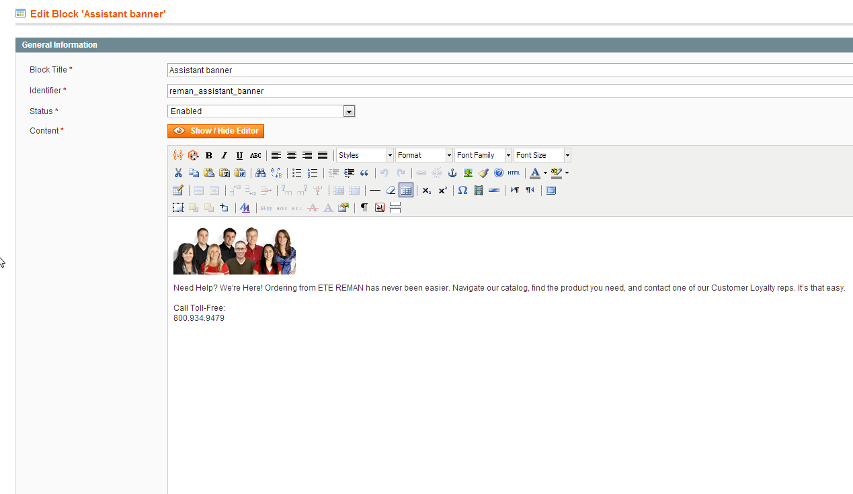

5. Then click on **Save Block** button to push your changes to Website

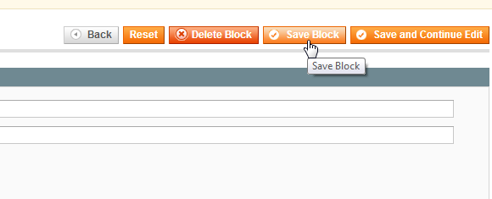

6. Before editing be aware of some style limitations:

* **Image width couldn't be more then 184px;**
* **Widget height is limited to 300 px , so don't put too much text on it;**